Flysheet First Pitching

Tent Pitching Instructions

Escapade
- Assemble the four poles and lay them parallel on the ground.
- Open flysheet on ground and position tent in desired direction.
- Locate pole sleeves on the flysheet and insert poles one at a time. Locate one end of each pole into corresponding pin system on flysheet.
- Push poles into an arch from opposite side and locate pole ends into corresponding pin system on flysheet.
- Peg out pegging points at both corners of one end of tent using pin-pegs supplied.
- Pull flysheet taut, away from pegged points, until tent takes shape. Peg the opposite two pegging points using the pin-pegs. Ensure the tent is in a straight line.
- Peg down poles through metal rings and remaining flysheet pegging points using alloy pin-pegs.
- Peg out ALL guy lines using the pin-pegs.

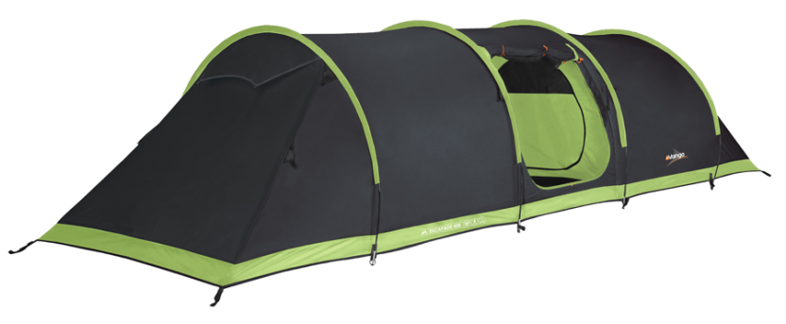
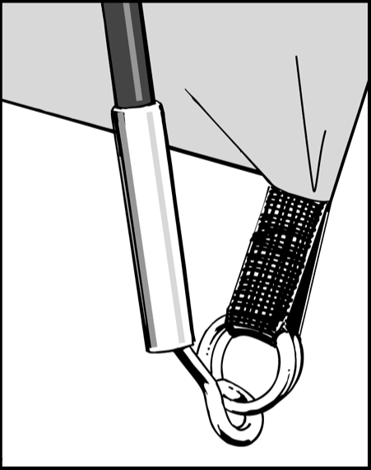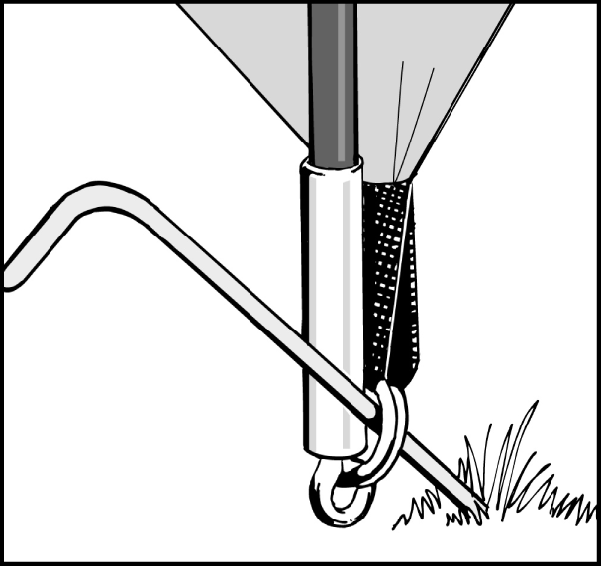
Inner
Figure 1
Figure 2
- Open out inner tents inside flysheet and position doorways to correspond with the porch entrance of the flysheet.
- For each inner, starting from the rear corners, attach the hooks on the groundsheet to corresponding rings on the base of the flysheet.
- Suspend the inner by attaching hooks of inner tent with rings on inside of flysheet. Start at the rear and work forwards.
- Attach hooks on front of groundsheet, to corresponding rings on base of flysheet.
- Attach porch groundsheet using the hooks to attach to the rings at the base of the flysheet wall.

The inner tent and flysheet can remain attached when pitching or packing. However, in humid or very wet weather, the underside of the flysheet may be coated with condensation. If this occurs, it may be advisable to detach the inner and pack it separately to avoid the inner tent becoming wet.

